January 8, 2020

(5:00 P.M.)

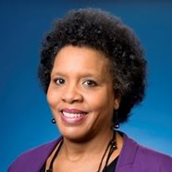
Council Member Brenda Priestly Jackson

District 10
Neighbors Advisory Council
Meeting

Notice is hereby given that the Honorable Brenda Priestly Jackson will host a District 10 Neighbors Advisory Council meeting on Wednesday, January 23, 2020 at 5:30 p.m. – 7:00 p.m. in the Auditorium of the Webb Wesconnett Regional Library (6887 103rd Street, Jacksonville, FL 32210). Members of neighborhood associations and interested parties in District 10 are invited to attend.

Please contact Kendra Mervin at (904) 255-5146 for additional information or correspondence.

BPJ/km

cc: Council Members/Staff
Cheryl L. Brown, Director/Council Secretary
Jessica Matthews, Chief of Legislative Services
Jeff Clements, Chief of Research
Kristi Sikes, Chief of Administrative Services
CITYC@COJ.NET
Office of General Counsel
Posted Notice Board – 1st Floor City Hall
Electronic Notice Kiosk – 1st Floor City Hall
Public Notice System – City Council Web Page
Media Box
File Box

